MCI - Lab 02
Muhammad Mughees Siddiqui 10047
Hamza Sami 09934
Task 0:
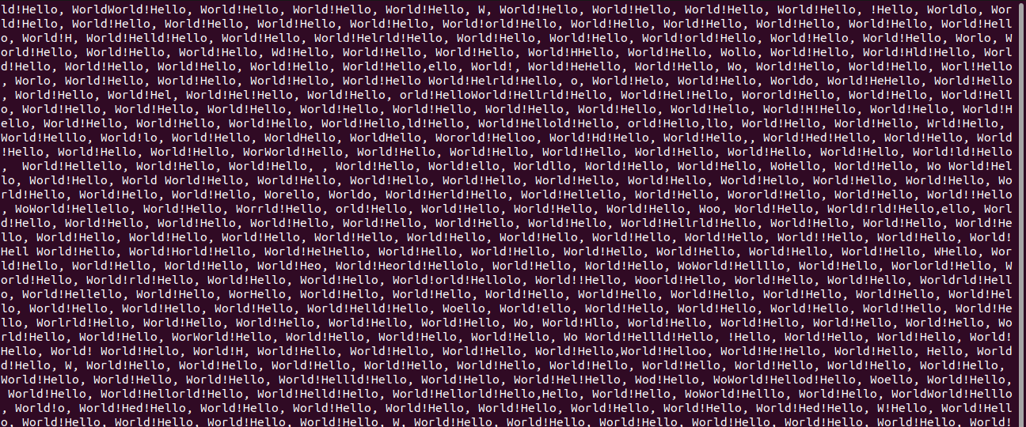
Task 1:
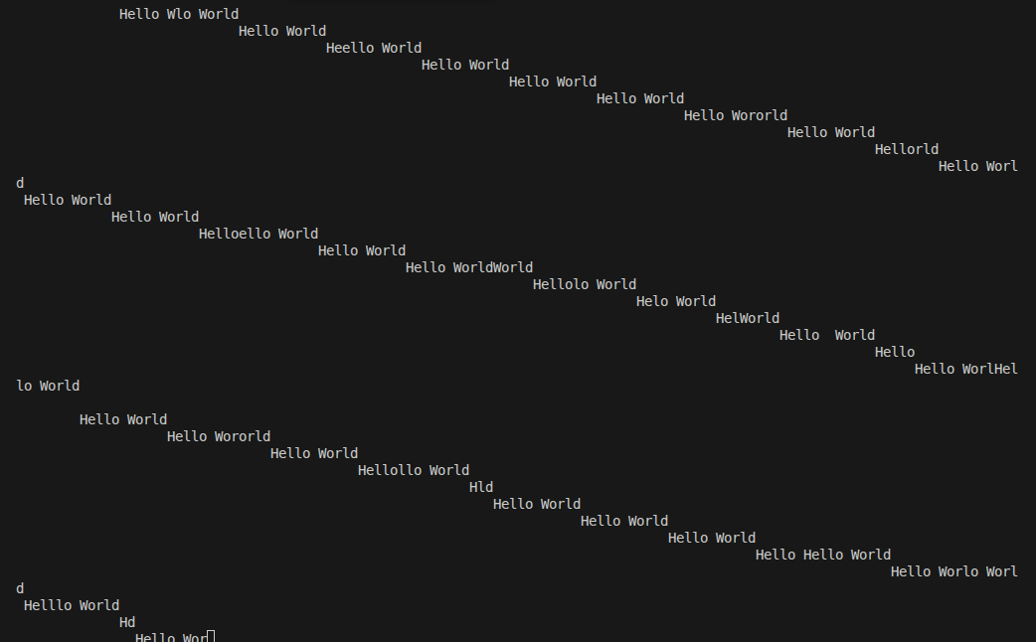

Task 2:
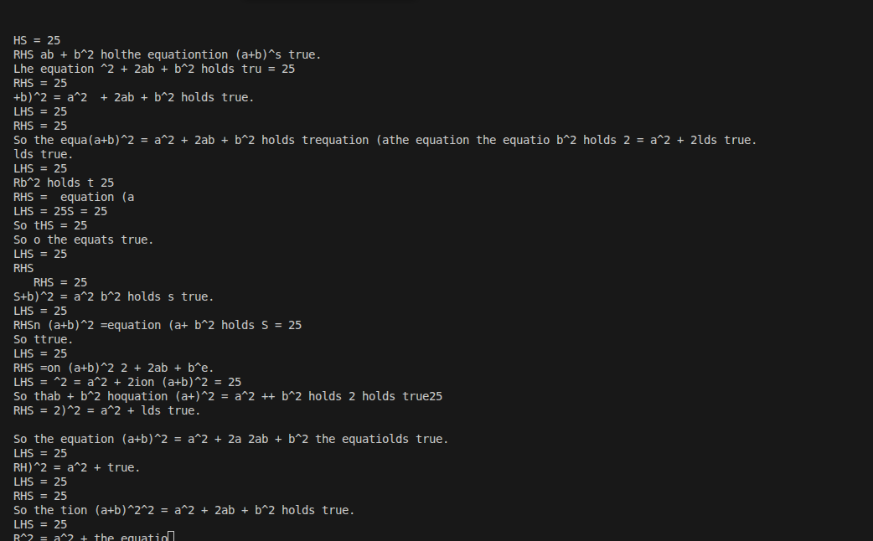
Task 3:
